Final Project Video Game Inventory Submission

This word document contains all screenshots relating to my final project and descriptions on what each one is trying to represent, and a repost of the previously submitted UML
UML:
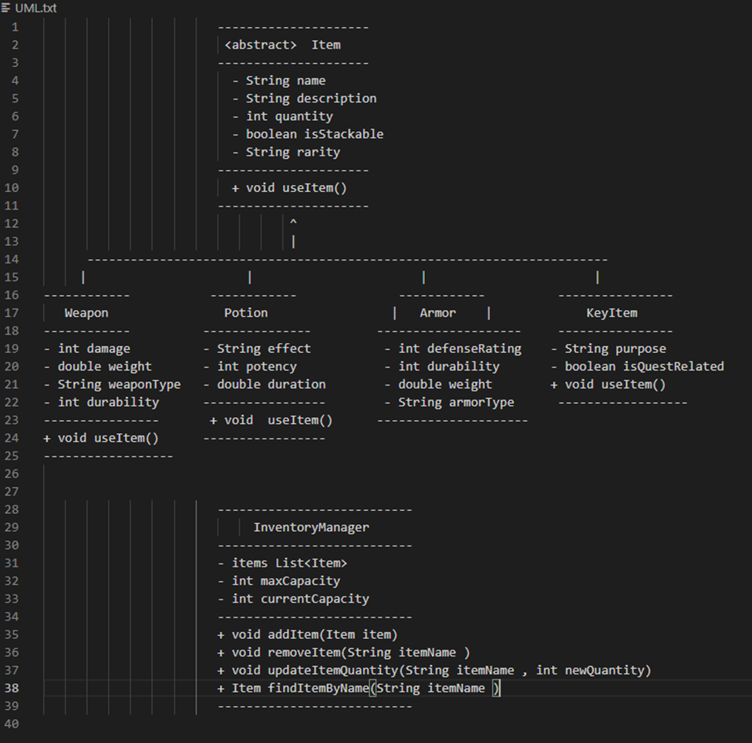

Image representing the UI popup when receiving a new item from the random item generation:
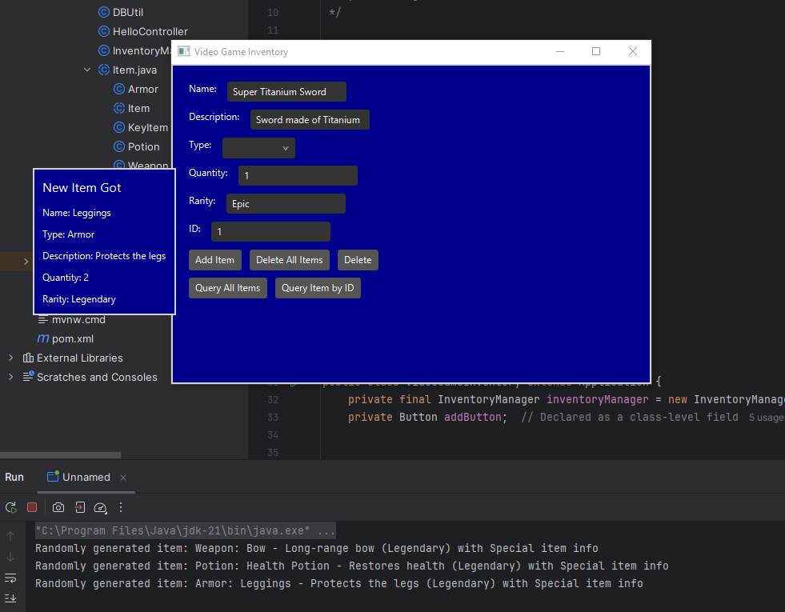

Image representing both the Randomly generated item UI and the custom created item being added UI:
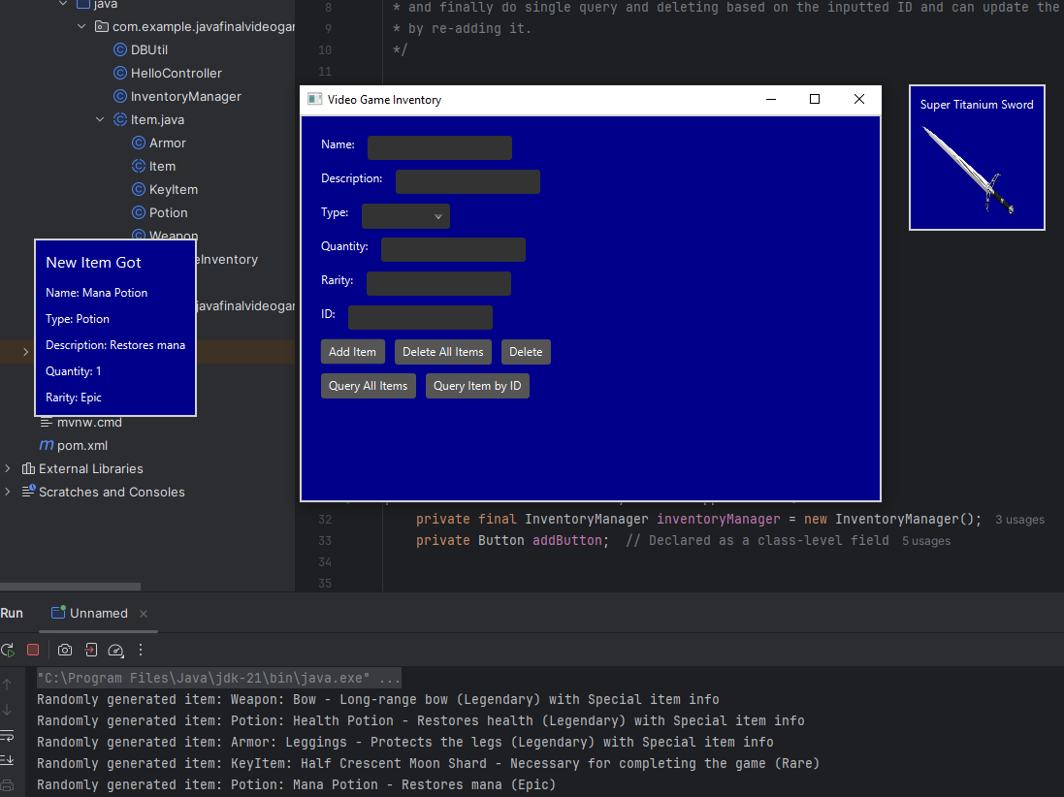

Images representing the Query single item button based on the inputted ID:
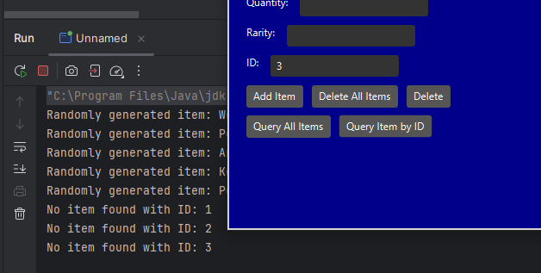
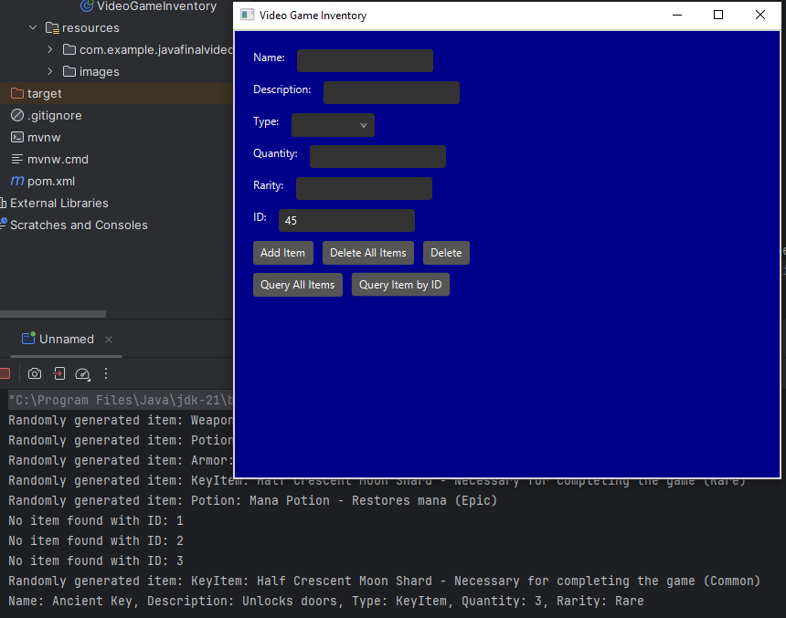

Images showing me successfully deleting an item at the inputted ID of 45 then trying to re-query it:
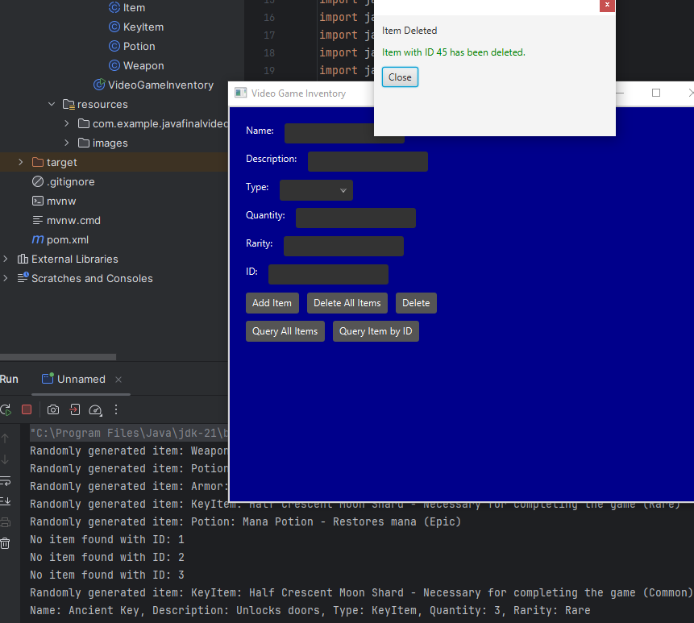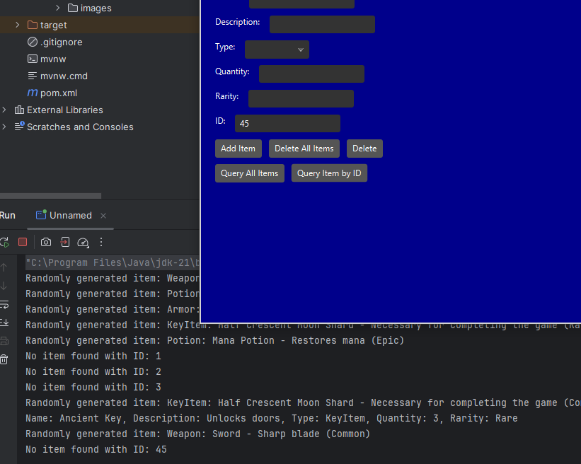

Image showing the query all button outputting all items inside the database to the console:
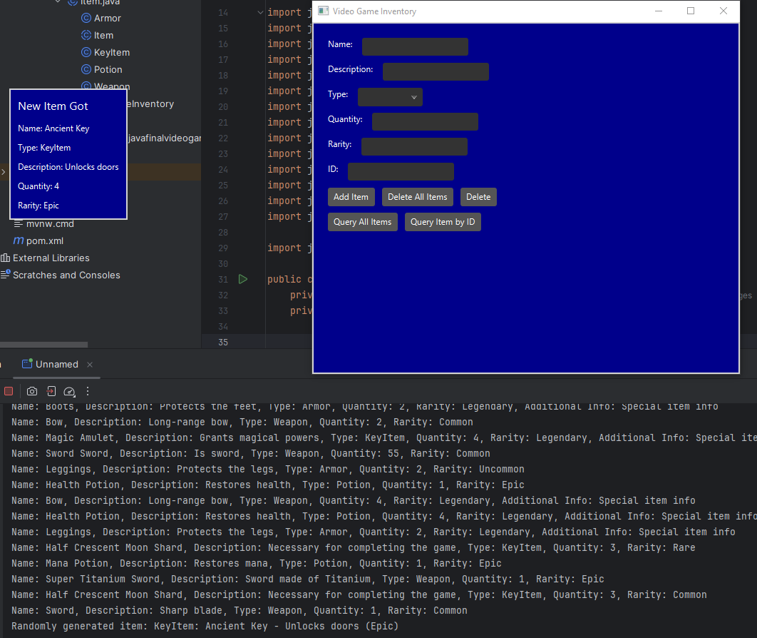

Image to show the items are in the database from the query all console print out:
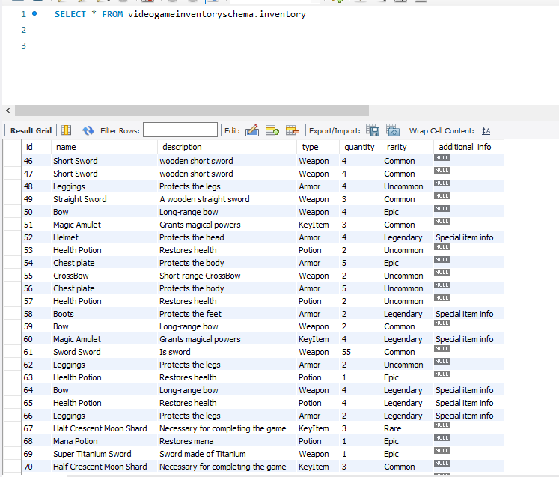

Images showing the delete all items button working and deleting everything then a new item gets added to the database:
